**[MT4 Trading Platform Quick Tips #1](http://www.forexstrategysecrets.com/blog/mt4-trading-platform-quick-tips-1.htm)**

This is a tip on the trading platform that shows how to get a full screen view of the charts then go back to a view with the Market Watch, Navigator, and Terminal on the view.  You can also just add one of the tools i.e. Terminal by following the instruction at the bottom.

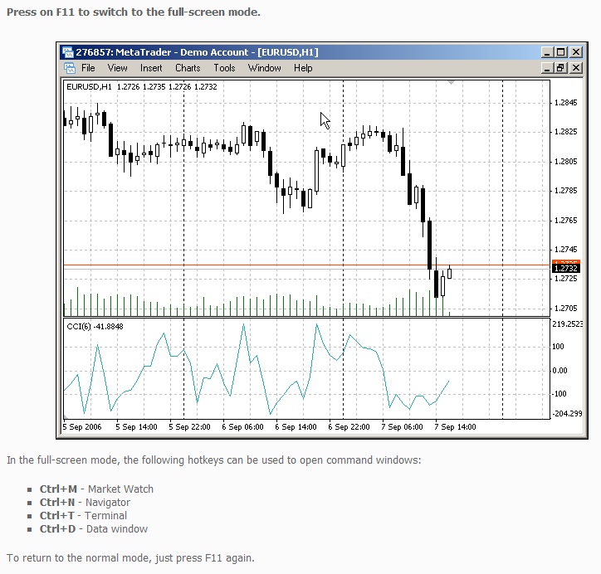

[**MT4 Trading Platform Quick Tips #2**](http://www.forexstrategysecrets.com/blog/mt4-trading-platform-quick-tips-2.htm)

Written by Kirk | [Leave a Comment](http://www.forexstrategysecrets.com/blog/mt4-trading-platform-quick-tips-2.htm#comments)

Topics: [MT4 Tips](http://www.forexstrategysecrets.com/blog/category/mt4-tips), [Trading Strategies](http://www.forexstrategysecrets.com/blog/category/trading-strategies), [Trading Tips](http://www.forexstrategysecrets.com/blog/category/trading-tips)

This is a fun feature if you would like to have some HOTKEYS to do things faster. Go to the Navigator Box, right click, from the drop down menu, select “set hotkeys”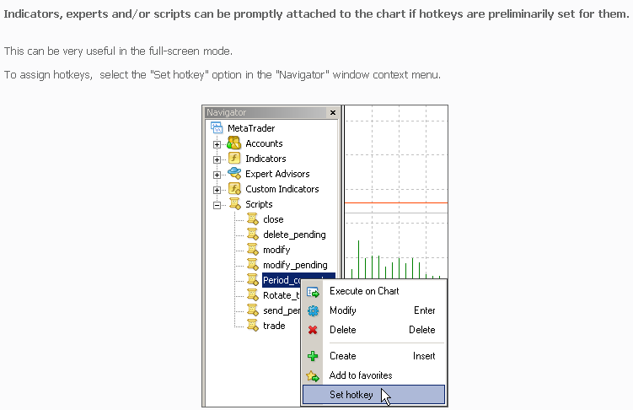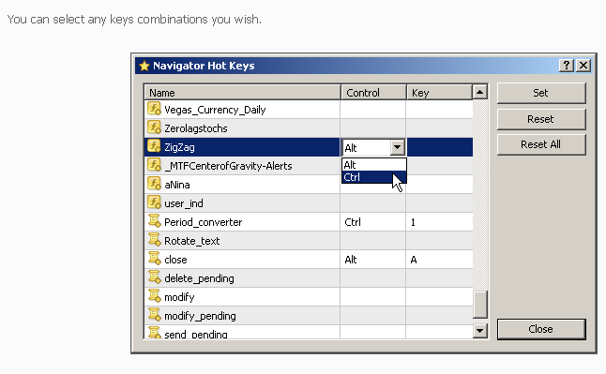

[**MT4 Trading Platform Quick Tips #3**](http://www.forexstrategysecrets.com/blog/mt4-trading-platform-quick-tips-3.htm)

If you need more space on your trading platform and still need to monitor your trades you can use the following tool.

**A double click with the left mouse button on the “Terminal” window title bar will minimize it to the bar of the current account status.**

Thus, some additional space will be free for the chart. You can also minimize the window by double-clicking with the left mouse button on the title of any tab in the window.

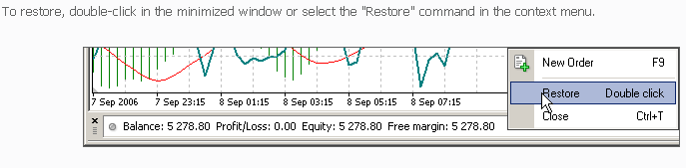

[**MT4 Trading Platform Quick Tips #4**](http://www.forexstrategysecrets.com/blog/mt4-trading-platform-quick-tips-4.htm)

This is a time saver if you use the same indicators or scripts all the time.

**Frequently used indicators/scripts/experts/accounts can be added to the “Favorites” group to have a faster access to them.**

To do so, click with the right mouse button on the name of the indicator/script/expert/account and select the command “Add to favorites”.

