**[MT4 Trading Platform Quick Tips #5](http://www.forexstrategysecrets.com/blog/mt4-trading-platform-quick-tips-5.htm)**

This is a good way to get rid of currencies you not trade to keep the market watch window organized 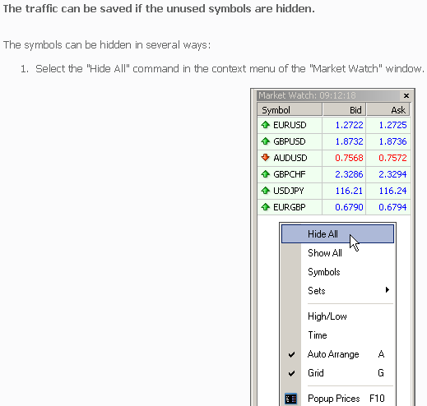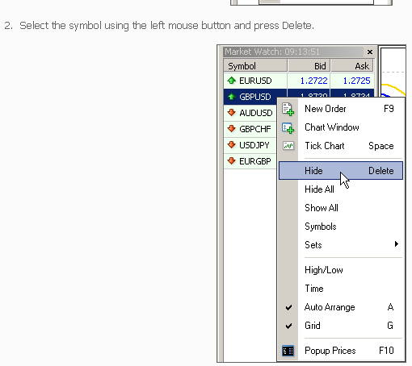mw-hide-all-4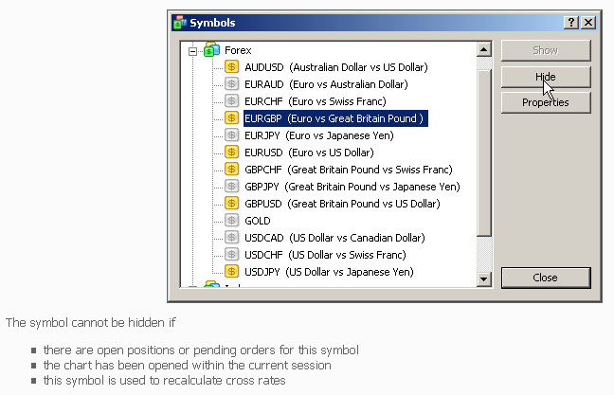

[**MT4 Trading Platform Quick Tips #6**](http://www.forexstrategysecrets.com/blog/mt4-trading-platform-quick-tips-6.htm)

This little tip is a fast way to group your currencies for quick reference when there is a good move in one group of currencies. i.e. if the JPY pairs are moving, you could group all the JPY pairs for easy access. Just right click in the Market Watch box to get the popup menu. **You can create several sets of symbols and switch between them, if necessary.** This can be very useful if you work with different groups of symbols (currency pairs, shares, futures, etc.). Hide all "excessive" symbols and save the set obtained. 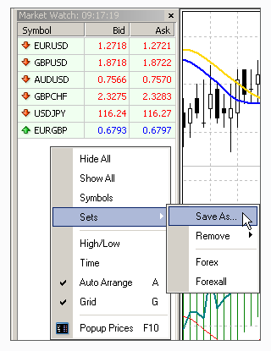

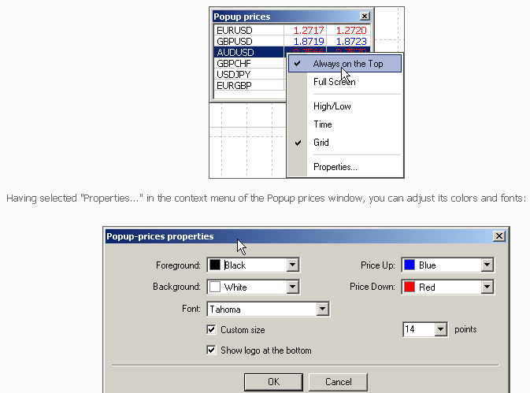

**[MT4 Trading Platform Quick Tips #7](http://www.forexstrategysecrets.com/blog/mt4-trading-platform-quick-tips-9.htm)**

This is the feature that we  use the most of all the great features

[Meta Trader 4 platform](http://www.metaquotes.net/)

has. **To call the "Crosshair" object, click the middle button of the mouse or press Ctrl+F.** This can be very useful when working in the full-screen mode. **You can check vertical distances and the amount of bars between two points using the ruler.** To do so, select the "Crosshair" object, click with the left mouse button on the first point in the chart and drag the cursor to the second point. 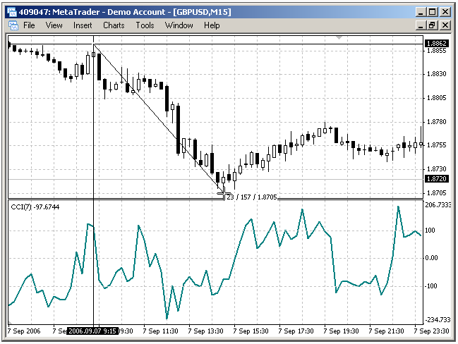The first number (23) is the count of bars, the second number (157) is the vertical distance in pips, and the third number (1.8705) is the bid price in the second point.