Home Page
Home tab

Free Forex Market Video Course

Simply enter your email address below and we'll send you 5 free videos revealing a simple formula for building a highly profitable forex career. You'll receive the first video in your email inbox immediately after registering…

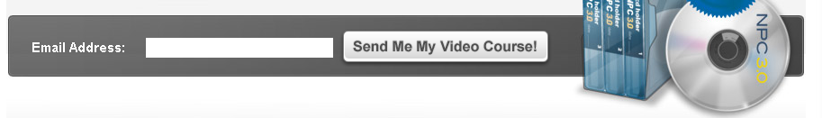
_______________________________________________________________

Whether You Want To Make An Extra $100 or $300 per Month, within the next 4 months, We'll Show You How!
Welcome to Forex Strategy Secrets Classroom!
If you're interested in learning how to build a successful trading career, with lasting income, and trading skills you can use for a lifetime. then you've come to the right place.
Many people don't realize it, but building a successful trading career doesn't have to be a difficult or confusing task. In fact, it can actually be a very simple and straightforward process when you know what you're doing.
Believe it or not, it's actually possible to have a live trading account up and making money not in years…but in a few short months. You don't need any prior experience, special talent, or technical knowledge. Anyone can build a live trading account where you make a few hundred dollars each and every month.
From the beginning you will learn how to increase your profits as your skills grow. Skills and account size go hand in hand.

________________________________________________________

We'll Show You How To Create A Profitable Website
Forex Strategy Secrets is a system that will teach you a specific, step-by-step formula for creating a profitable trading account from scratch, and give you the tools to do it as quickly and easily as possible. Our step-by-step video training course, alerts package, trading rooms, and the bi monthly coaching webinars enable you to gain the trading skills, you need to generating income quickly.

______________________________________________________________

The Forex Strategy Secrets Program
The powerful combination of quality training, "done for you" resources, and personal coaching is what sets FSS apart from any other program or 'system' out there.

When you join FSS, you get immediate access to all of our features and services, including:
Video basic training
- MT4 instruction
- Jump Start
- Launch Pad
Trading Alerts Package
- Norwood Alert
- Trend Alert
Coaching & support
- Bi Monthly Webinars
Live Trading Instruction
- Trading room
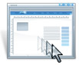
Video-Based Training: Our video course will walk you step-by-step through the proven formula for building a profitable trading account. You get to watch over our shoulders as we trade live, right before your very eyes. You'll get to see every single step that is required as we explain the reason behind.
______________________________________________________________
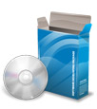
Trading Alerts Package: The FSS forex trading systems include a variety of simple, yet powerful trading finding alerts that drastically simplify the process of building a profitable live forex-trading account. A few of the tools include The Norwood Alert, and the Trend Alert. You don't need any technical knowledge to use them. If you can follow the simple step-by-step videos, you can quickly learn how to have trades brought to your attention at a faster rate than 5 people can find them manually.
______________________________________________________________
Coaching & Support: Twice a month you'll be invited to join us on a live, members-only webinars and coaching calls designed to accelerate your business to the next level. You'll learn the latest, most cutting-edge strategies for making money trading the forex market and have the opportunity to ask us anything you'd like about becoming a successful forex trader. Every session includes group Q&A, 1 on 1 coaching and trading instructions.
______________________________________________________________

See How Trading Is Done Live and in Real Time: Every month, you'll receive 12 two-hour live trading sessions. These trading room sessions come with full exposure to how we trade live using the same system you will be using. You will see other traders making 100’s of pips per day and 1000’s of pips per week. You can follow along and see how trades are managed. You will see how traders handle the emotion of trading. Each session includes a group Q&A 1 on 1 coaching at the end of the trading room.

______________________________________________________________

Getting Started Is Easy
You can get started building your profitable forex trading account today. If this is your first time to Forex Strategy Secrets, go ahead and click the "learn more" button below to get more information about what you'll receive with your membership. If you've been here before, or already know about our program and want to get started right away, click the "join now" button to create your membership account.



