Jed & Kirk

Just wanted to let you know that I started demo trading yesterday with the AUD/JPY and I ended up with 174 pips. I watched every video from Launch Pad and I made my first trade today and wham 174 pips, I was so excited. You guys are geniuses. I will watch the videos again tu master my skills and I will eventually get the Nth degree plus the Norwood Alerts to maximize my trading profits. Thanks guys

Eugene

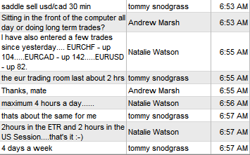

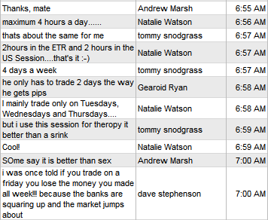

Dear Mr. Kirk,

On the contrary Thank you for letting me in your trading room

and showing how a professional takes decision before entering a trade.

And i appreciate how much you talk to us, it really is very tiring - and i wonder if others know this -to talk non stop 3 days a week for almost 2and half hours.

It was good hearing Ms June talking,

In the european session i cannot hear . No sound.

But i really know how difficult it is to trade and simultaneously conduct a webinar.

Best Regards

P. Mitra

Hello,

I have just recently joined your program and have not finished watching all of the Nth Degree videos, but I took 6 demo trades today. Here are my results:

Short USDCHF +88

Buy NZDJPY +37

Buy GBPUSD +126

Buy GBPJPY +7

Buy EURJPY -27

Buy EURUSD -27

Total: +204

The 2 losses I took would have been much smaller or possibly break even, but I had to leave for a doctor's appointment around 10am CST and was gone for about 2 hours. I was using a manual trailing stop moving to high/low of previous bar. I'm looking forward to learning more. Thanks.

Mark B.

Hi Kirk and Jed,

I just wanted to pass on my compliments and gratitude for the high

quality customer service that you afforded me during my recent

difficulties installing the NAs on my computers.

All is now fixed - thanks to your understanding.

Thank you.

Peter H.

Australia

Jed and Kirk

Thanks a lot for the education videos and theory I must truly admit

the things you are teaching me I would never have learned anywhere

else even with years of trading thanks and God Bless you.

A. Plaatjies

Jed,

You guys are to be congratulated on actually putting out some good and useful information about trading. So much of the stuff I get is scamming junk from wannabe traders.

All the best,

Bill H.